ve

**Immigration User Manual v 2.0**

* **Central Equipment Identity Register System Admine Portal**

Document Change History

|  |  |  |  |
| --- | --- | --- | --- |
| Version | Change Type | Description | Date |
| Draft |  | Submitted for internal review | February 2020 |

Contents

Document Change History i

Contents ii

Figures iii

1 Overview 1

1.1 Scope 1

1.2 Acronyms & Abbreviations 1

1.3 Conventions 1

2 Immigration officer Operations 3

2.1 Application Overview 3

2.2 Logging into the Application 3

2.3 Application User Interface 4

2.4 Grievance 6

2.5 Filter Grievance 9

2.1 Sorting Grievances 10

2.2 Exporting Grievances 11

2.3 Search 12

Figures

Figure 1: Login 3

Figure 2: Search Page 4

Figure 3: Change Password 5

Figure 4: Change Password 6

Figure 5: Grievance – View All 6

Figure 6: Grievance – Create Grievance User ID Enter Option 8

Figure 7: Grievance – Create Grievance 8

Figure 8: Grievance – Filter Option 10

Figure 9: Sort Grievances 11

Figure 10: Grievance Management 11

Figure 11: Open or Save Exported Grievance File 12

Figure 12: Exported Grievances 12

Figure 13: Search – IMEI 12

Figure 14: Search – Search IMEI 13

# Overview

## Scope

The objective of this manual is to help Immigration officer to search IMEI and raise grievance using the CEIR (Central Equipment Identity Register) application.

## Acronyms & Abbreviations

| **Acronym** | **Full Form** |
| --- | --- |
| CEIR | Central Equipment Identity Register |
| IMEI | International Mobile Equipment Identity |
| PDA | Personal Digital Assistant |
| TAC | Type Allocation Code |
| TRC | Telecommunication Regulator of Cambodia |

## Conventions

| **Information** | **Convention** |
| --- | --- |
| UI elements  (such as names of windows, buttons, and fields) | Bold |
| References  (such as names of files, sections, paths, and  parameters) | *Italics* |
| **\*** | Indicates a mandatory field or column |

# Immigration Operations

## Application Overview

The CEIR (Central Equipment Identity Register) Immigration officer Portal is used in various work-flow in the CEIR application.

Immigration officer perform the following tasks:

* Grievance Management
* Register Device

## Logging into the Application

Before login, the Immigration officer must register in the application.

To register:

1. Enter the CEIR Home Portal URL in the browser address bar. This opens the CEIR Home Portal page.

Figure 1: CEIR Home Page

1. Select **Immigration** from the **Registration** list.

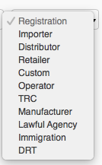

The **Immigration Registration** page appears. The user needs to fill in the following information.

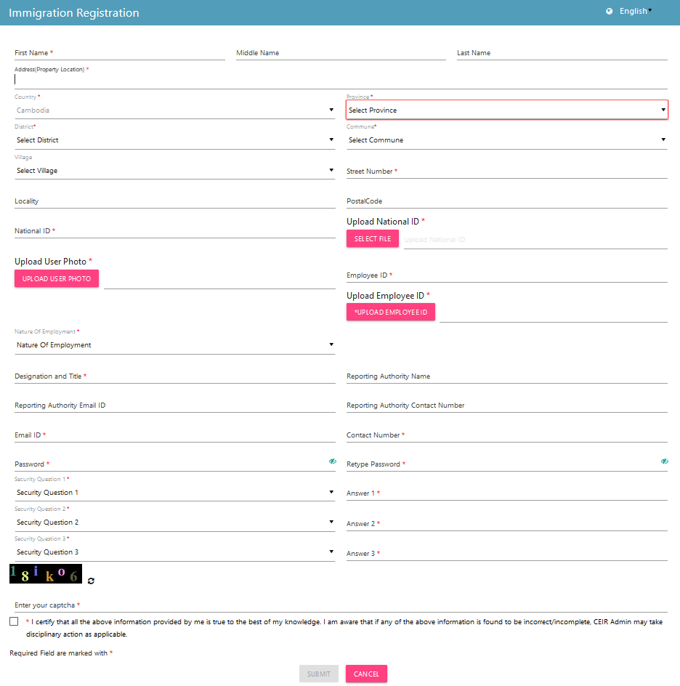

Figure 2: Immigration Registration

1. **\*First Name**: Enter the first name.
2. **Middle Name**: Enter the middle name (if any).
3. **\*Last Name**: Enter the last name.
4. **\*Address**: Enter the Immigration officers’ address:
   1. **\***Street Number
   2. Village
   3. Locality
   4. **\***District
   5. **\***Commune
   6. **\***Province
   7. **\***Country
5. **\*Arrival Port**: Select the arrival port from the list (Land, Water, Air).
6. **\*Port Address:** Select the port address from the list
7. **\*National ID:** Enter the national ID of the agency personnel.
8. **\*Upload National ID**: Upload the image of the original national ID of the personnel. This can be a pdf or image (.jpeg) of size not more than 2 MB.
9. **\*Upload Photo**: Upload the photograph of the personnel. The photograph can be a pdf or image (.jpeg) of size not more than 2 MB.
10. **\*Employee ID**: Enter the employee ID.
11. **\*Upload Employee ID Card**: Upload the image of the Employee ID card. The photograph can be a pdf or image (.jpeg) of size not more than 2 MB.
12. **\*Nature of Employment**: Select the type of employment of the personnel:
    1. Permanent
    2. Temporary
    3. Contract
13. **\*Designation and Title**: Enter the designation of the agency personnel.
14. **Reporting Authority Name**: Enter the name of the officer to whom the personnel reports to.
15. **Reporting Authority Email ID**: Enter the mail ID of the officer to whom the personnel reports to.
16. **Reporting Authority Contact Number**: Enter the contact number of the officer to whom the personnel reports to.
17. **\*Email**: Enter the mail ID of the personnel. This mail ID would be used for communication
18. **\*Contact Number**: Enter the mobile number of the personnel. The agency would receive notifications at this mobile number.
19. **\*Password**: Enter a login password. This is the password that would be used to log into the CEIR Importer Portal application.
20. **\*Confirm Password**: Re-enter the password for confirmation.
21. **\***Select three security questions and enter an answer for each question. This is required by the system when the importer forgets the password. In such a situation, the system requires identification to authenticate the importer. These security questions are used for authentication of the importer.
22. **\***Enter the captcha shown on the page. This is required to prove that the importer is not a robot.
23. **\***Select the declaration check box.
24. Click **SUBMIT**.

An OTP is sent to the Immigration officer’s mail ID and contact number.

Figure 3: Verify OTP

The Immigration officer is prompted to enter both the OTPs in the page for verification.

Figure 4: Enter OTP

Enter the two OTPs and click **Done**.

If the two OTPs match, the following message appears. If the OTPs do not match, click **Resend OTP**. The two OTPs are resent, one to the contact number and the other to the mail account.

After the OTPs are verified successfully, the registration request is sent to the CEIR Admin. The approval turnaround time is 2-3 days. After approval from the CEIR Admin, a mail containing the Immigration officer’s registration ID is sent to the Immigration officer’s mail account. This registration ID is a unique automatically generated ID. This ID is the login username for access to the CEIR Immigration officer Portal application.

To start using the application, log into the application.

To login:

1. Open the browser and enter the CEIR Immigration officer Portal URL in the address bar. The login screen appears.

Figure 1: Login

On the top right corner of the login screen is the **Language** option. The application supports two languages: **English** and **Khmer**. On selecting a given language, all the field and column labels in the application appear in the selected language. All user inputs are, however, in English.

1. Next, enter the assigned login username and password.

Username is the registration ID that is sent on mail to the System Admin after successful registration in the system.

1. Enter the captcha.
2. Click **LOGIN**.

If the login and password are incorrect or the captcha is not correct, an error message appears, and you are prompted to re-enter the login details.

On entering correct information, the application Search page appears.

If the Immigration officer forgets the assigned password, then the same need to request from the System admin. The **Forgot Password** link work for external user who register themselves from the DMC portal

## Application User Interface

On logging into the application successfully, the CEIR Immigration Portal Home page appears.

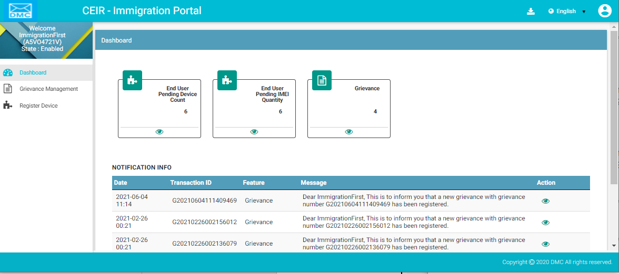

Figure 2: Home Page

The Home page has all the feature menus on the left panel.

The top right corner of the screen displays the following menu options:

* **Download**: Click to download this user manual.
* **English**: Select **English** or **Khmer**. All the field and column labels appear in the selected language. User inputs are, however, in English.

* A close up of a logo

  Description automatically generated(**User profile**): Click on it to see the following menu:

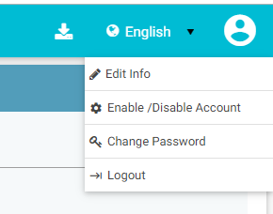

*  (**Edit Info**): Click on it to modify the registered information. The **Edit Information** page opens.

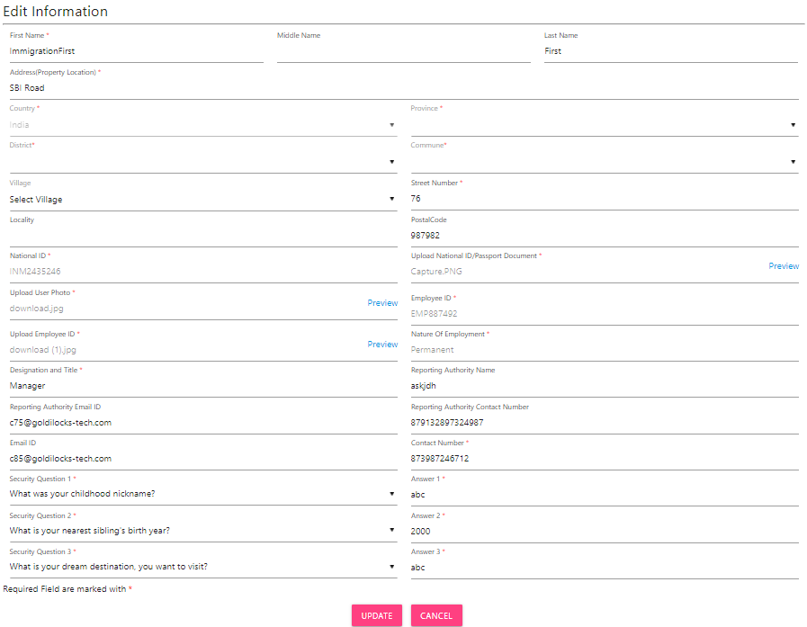

Figure 10: Edit Information

1. Make the required changes.
2. Click **Submit** to save the changes.

*  (**Change Password**): Click on it change the login password.

Figure 11: Change Password

1. **Old Password**: Enter the existing password. Click  to see the password characters being entered. Click on it again to hide the password characters. This works like a toggle key.
2. **New Password**: Enter a new password.
3. **Confirm Password**: Re-enter the new password to confirm the password.
4. Click **SUBMIT**.

*  (**Enable/Disable Account**): Operator can deactivate their account or disable/enable their account.
  + Deactivating an account means deleting the login account. After the operator’s account is deleted, he/she can raise a grievance to reactivate it when required. The grievance is sent to the CEIR administrator who reactivates the account. After reactivation, the operator can use the same login username and password to log into the application.
  + When the account is disabled, the operator can only view information and not add or modify information in the application. After the account is disabled, they can enable it using the same menu.

Figure 12: Manage Account

1. Select **Deactivate** or **Disable**.
2. Click **SUBMIT**.

## Dashboard

The Dashboard provides a quick display and access to the following information:

* End User Pending Device Count
* End User Pending IMEI Count
* Grievances

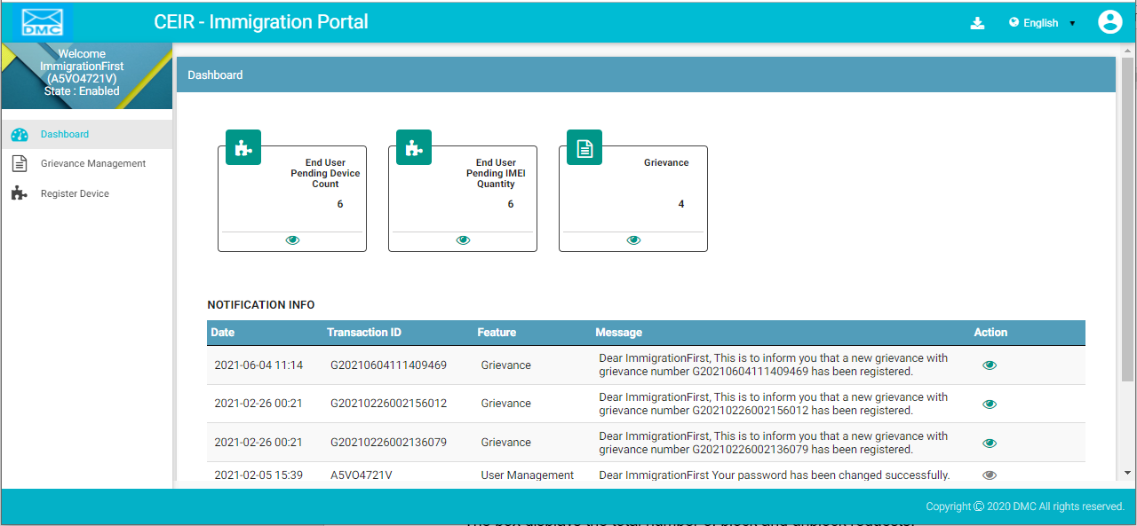

Figure 13: Home Page

**End User Pending Device Count**

The box displays the total number of end user device requests that are pending for approval.

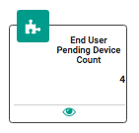  
Click  (**View**) to access the **Register Device** dashboard. Refer to *Register Device* for more information.

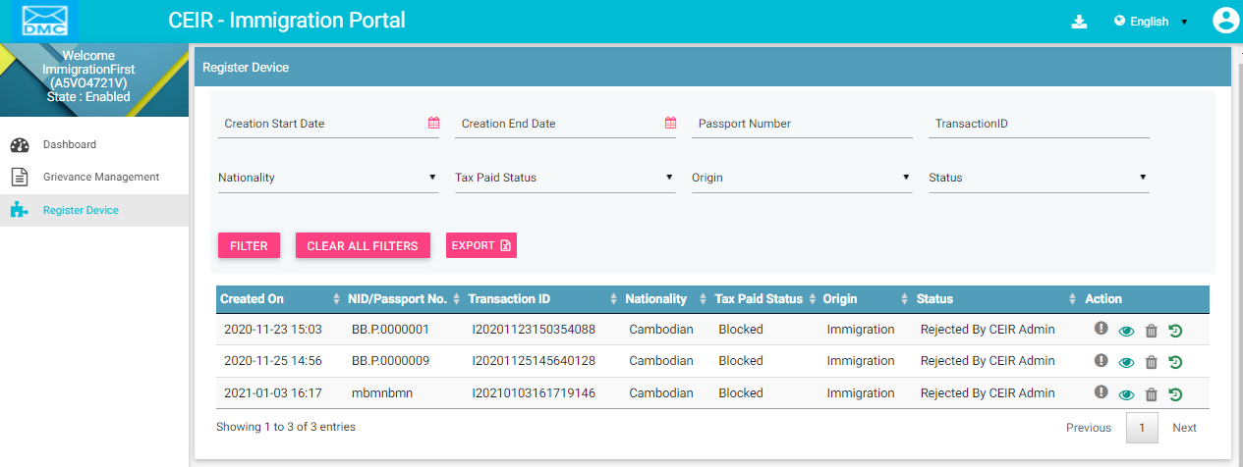

Figure 17: Register Device

**End User Pending IMEI Count**

The box displays the total number of end user device IMEI that are pending for approval.

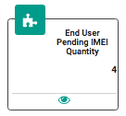

Click  (**View**) to access the **Register Device** dashboard. Refer to *Register Device* for more information.



Figure 18: Register Device

**Notification Information**

This section displays the most recent notifications. System Admin can configure the number of notifications that are displayed on user dashboard.

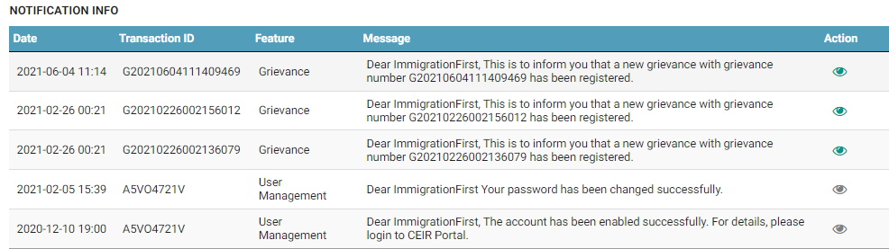

Figure 19: Home Page

Notifications are of two types.

1. Notifications that provide only information. For example, a notification informing the Immigration officer about the account status is an information only notification because it requires no action. The **View** icon () is disabled in such notifications.



1. Notifications that require some action by the Immigration officer. For example, a notification about the consignment approval by the CEIR Admin and need clearance from Immigration officers The **View** icon () is enabled in such notifications. Click  (**View)** to access the relevant page of the notification.



The notification panel has the following columns:

* **Date**: Date of sending the notification
* **Transaction ID**: Transaction ID of the consignment or stock or grievance or register device request for which the notification is sent. If the notification is related to the Immigration officer account, the login username is shown instead of any transaction ID.
* **Feature**: This is the name of the feature for which the notification is sent. For example, if the notification is for a consignment, the feature name **Consignment** is shown. If the notification is concerning a stock transaction, the feature name **Stock Management** is shown. The feature name is the one shown in the left panel of the Home page.
* **Message**: This is the message of the notification. An example is shown below.



* **Action**: This shows the **View** icon. It is activated  if the Immigration officer can click on it else it is disabled .

## Grievance

Immigration officers can raise grievance request on behalf of the user.

To raise the request:

1. Select **Grievance** in the left panel

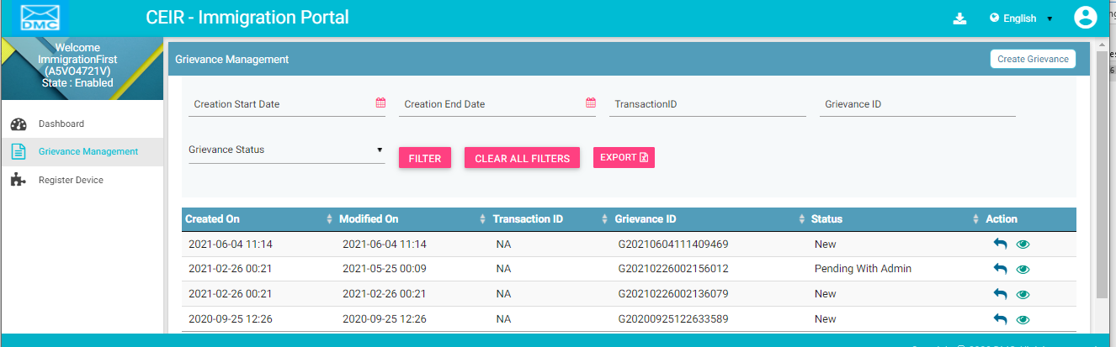

Figure 5: Grievance – View All

The following columns are seen in the Grievance Page

| **Column** | **Description** |
| --- | --- |
| Created On | This is the date when request is created |
| Modified On | This is the date when request is last modified. |
| Transaction ID | Transaction ID of the request for which the grievance is raised. |
| User ID | User ID of the user for whom CCA has raised the grievance. |
| User Type | User Type of the user for whom CCA has raised the request. |
| Grievance ID | Grievance ID of the grievance |
| Raised By | This parameter denotes who has raised the grievance. The Value of this parameter would be userid |
| Status | The grievance goes through different status modes.   * New: When a grievance is raised. * Pending with CEIR Authority: When a response is awaited from the CEIR Admin. * Pending with User: When a response is awaited from the importer.   Closed: When the CEIR Admin closes the grievance. |
| Action | This displays different actions that can be performed on a grievance.   * Reply : This is used to respond to the grievance. The response is given by the CEIR administrator. The exchange of responses is done until the grievance is closed. * View A close up of a logo    Description automatically generated: This is used to view the grievance response history. The CEIR admin can see all the responses exchanged for any grievance |

Click on “Create Grievance” to create a grievance for a user.

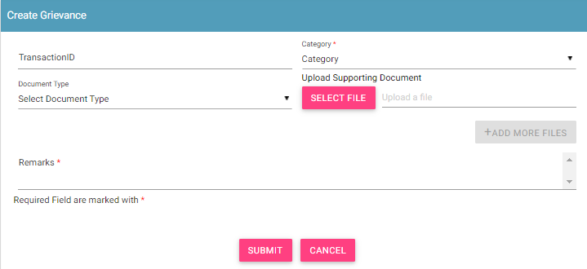

Figure 7: Grievance – Create Grievance

1. Enter the following information:
   1. **Transaction ID**: Enter the transaction ID of the type approval request if the grievance is related to a type approval request
   2. **\*Category**: Select the category of the grievance. The options are:

* Type Approval Related: Problem in reporting type approval request etc.
* Other: Problem with any other aspect of the application
* Registration Related: Problem with registering information in the application.
* Consignment Related: Problem related to consignment request
* Stock Management Related: Problem related to stock management request
  1. **\*Remarks:** Enter information about the grievance raised. This helps the administrator to understand the problem in detail.
  2. **Document Type:** Select the type of identification or another document that is to be uploaded. The options are:
* Passport
* Visa
* NID (National ID)
* Photo
* Other
  1. **Upload Supporting Document:** Click **Select File** to upload the document selected in **Document Type**.
  2. To upload more documents,click **+Add More Files.**

This adds two more fields: **Document Type** and **Upload Supporting Document**.

1. Click **SUBMIT**.

A grievance ID is generated and assigned to the registered grievance. A mail is sent to the use on whom behalf grievance has been raised.

## Filter Grievance

Immigration officers can view selective information by defining specific values in the listed fields. For example, Immigration officers can view the specific request during specified date by selecting start/end date.

To view specific request:

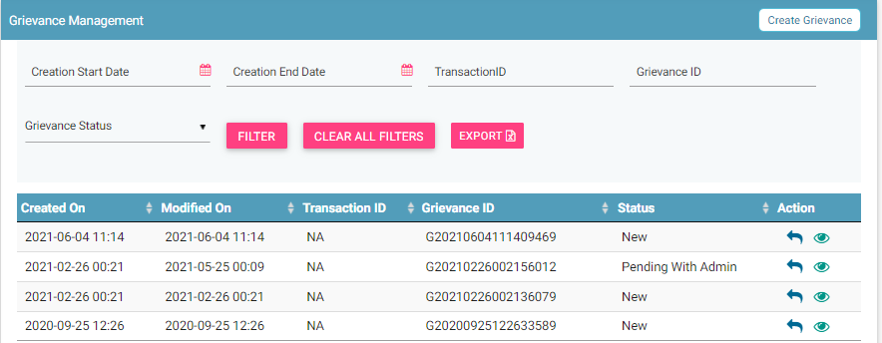

Figure 8: Grievance – Filter Option

1. Enter the required value in one or more of the listed fields:

* **Start Date:** Select the start date
* **End Date:** Select the end date
* **Transaction ID:** Enter the Transaction ID
* **Grievance ID:** Enter the Grievance ID
* **User ID:** Enter the user ID
* **User Type:** Select the type of user
* **Grievance Status:** Select the status of grievance.

1. Click **FILTER**.

The parameter that matches the specified values is shown in the dashboard.

The user can clear all filters using the “**Clear All Filters**” button. This will reset all the filter values applied on the page and the data table will be refreshed.

## Sorting Grievances

By default, all records displayed are sorted based on modified date. User can sort the records by clicking the arrow button on header in the table displayed.

On first click, the records are sorted in ascending order. When user clicks the arrow buttons again, records are sorted in descending order.

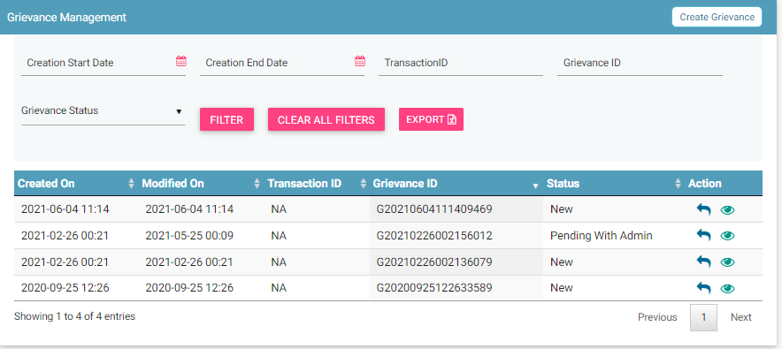

Figure 9: Sort Grievances

## Exporting Grievances

All the uploaded grievances can be downloaded in a **.csv** file. This is done using an export utility.

To export the grievances:

1. Click **Export** (seen on the top right corner of the **Grievance Management** page).



Figure 10: Grievance Management

The following page appears.

Figure 11: Open or Save Exported Grievance File

1. Click **Open with** to view the file.

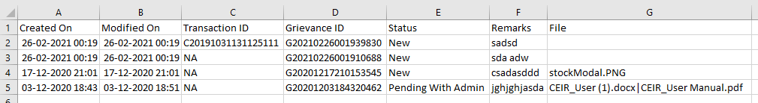

Figure 12: Exported Grievances

Instead of exporting all the grievances, personnel can export filtered grievances. First, filter the grievance data based on specific filters (refer to *Filter Grievances*) and then export the filtered grievances using the export utility.

## Registering Devices

The Immigration officials use the CEIR application to register devices that are brought into Cambodia by foreigners/local Cambodian users. The registered device is used to build a device database. The end user has to pay taxes on the devices as per the applicable CEIR policy

### Registering Imported Devices

To register a device:

1. Select **Register Device** in the left panel of the home page.

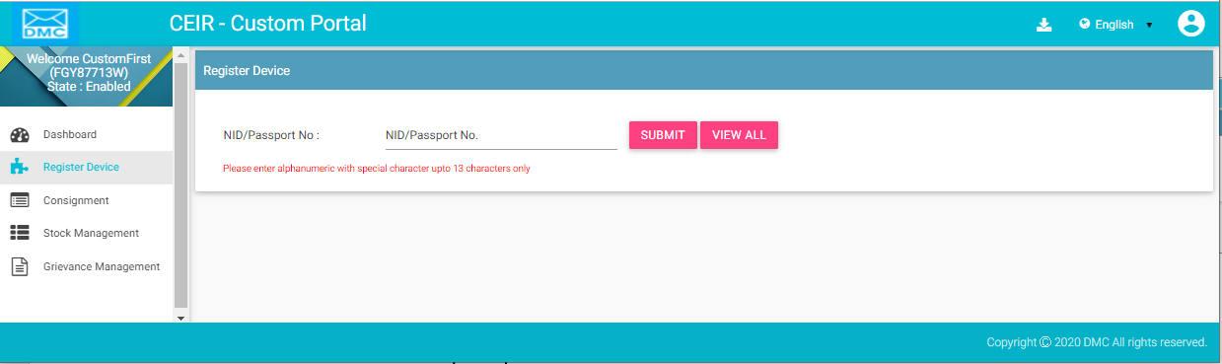

Figure 47: Register Device

1. Enter the NID passport number.
2. Click **Submit**.

If there are any existing registered devices that are associated with the passport number entered, the following page appears.

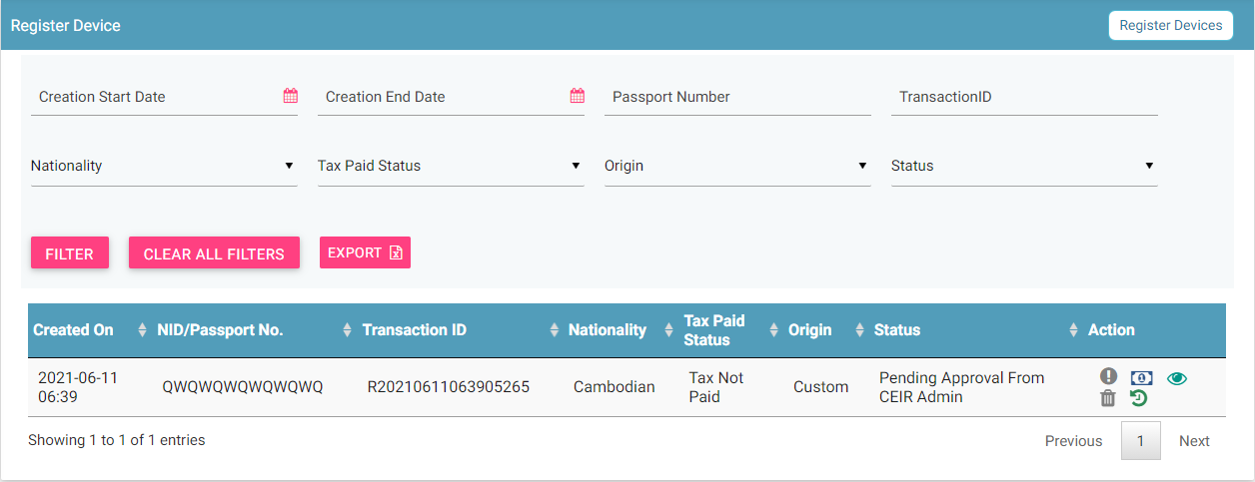

Figure 48: Register Device

1. Click on **Register Device** on the top right of the form. Following form appears.

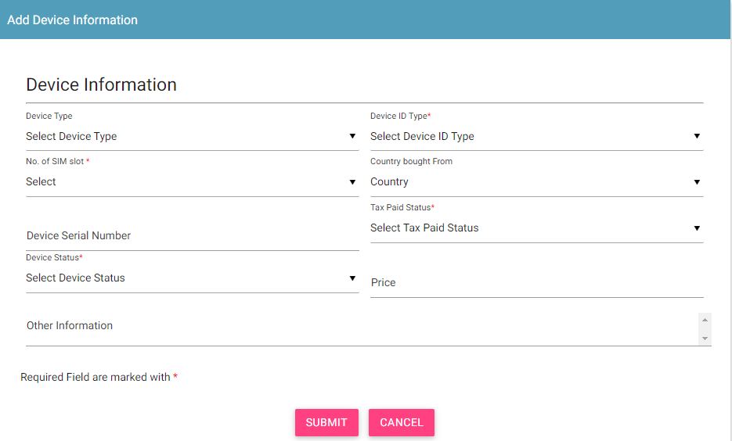

1. Enter the following information:

* **Device Type**: Select the type of device:
  + Mobile Phone
  + Feature Phone
* \***Device ID Type**: Select the type of ID of the device that would be entered for identification:
  + IMEI
* \***No. of SIM slot**: Number of multiple SIMs the device supports (1-4)
* **Country bought from**: Select the country from where the device was bought.
* **Device Serial Number**: Enter the serial number of the device.
* \***Tax Paid Status**: Select the tax paid status
* **Price**: Price of the device
* \***Device Status**: Select the status of the device:
  + New
  + Old
* \***IMEI**: Enter the ID value(s). A maximum of 4 ID values can be entered.
* Click **Submit**.

A unique transaction ID is generated, and the request is processed internally. The registration request appears on top of the page.

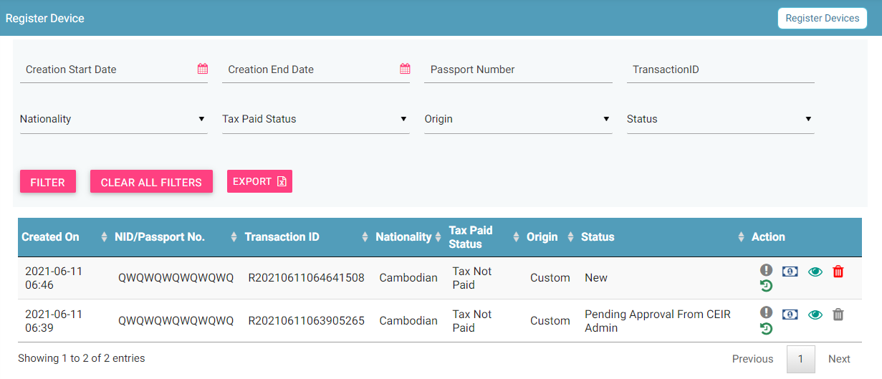

Figure 50: Register Device

If the passport number/NID is not found in the system and there is no device registered with the passport, the following page appears.

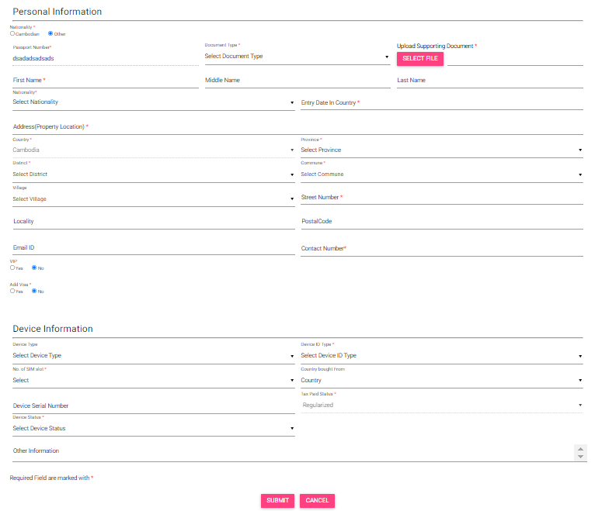

Figure 51: Register Device

Enter information about the person who is visiting Cambodia.

1. Enter the following information:

**Personal Information:** Enter the personal details of the person.

* \***Passport Number**: NID/Passport number entered by the user at the time of opening the register device form will be pre-filled by the system here.
* \***Upload Supporting Document**: Select the type of document to be uploaded for identification.
  + Passport
* \***First Name**
* **Middle Name**
* **Last Name**
* \***Nationality**
* \***Entry Date in Country**: Select the date of entry in Cambodia.
* \***Address (Property Location)**
* \***Street Number**
* **Village**
* **Locality**
* \***District**
* \***Commune**
* **Postal Code**
* \***Country**
* \***Province**
* **Email**
* \***Contact Number**
* **VIP**: Select Yes or No depending on the status of the person.
  + Department Name: Enter the department of the person. This is applicable only if the person is a VIP.
  + Department ID: Enter the department ID of the person. This is applicable only if the person is a VIP.
  + Upload Department ID Image: Click File to upload an image of the department identification of the person. This is applicable only if the person is a VIP.
* **Add Visa**: Select Yes or No depending on whether the person has a visa.
  + Visa Type: Select the type of visa. This is applicable only if the person has a visa.
  + Visa Number: Enter the visa number. This is applicable only if the person has a visa.
  + Visa Expiry Date: Select the expiry date of the visa. This is applicable only if the person has a visa.
  + Upload Visa Image: Click File to upload the visa image. This is applicable only if the person has a visa.

**Device Information**

* **Device Type**: Enter details of the device.
* \***Device ID Type**: Select the type of ID to be entered for the device:
  + IMEI
* \***No. of SIM slot**: Number of multiple SIMs the device supports (1-4)
* **Country Bought from:** Select the country
* **Device Serial Number:** Enter the serial number
* \***Tax Paid Status:** Select the tax paid status
* **Price:** Enter the price
* \***Device Status:** Select the device status
* \***IMEI**: Enter the value of the IMEIs of the device.
* Click **Submit**.

A unique transaction ID is generated, and the request is processed internally. The request can be seen on top of the page.

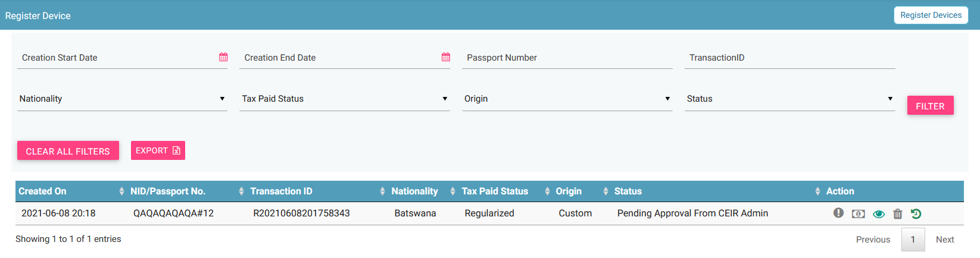

Figure 52: Register Device

For each request, the following information is displayed:

| **Column** | **Description** |
| --- | --- |
| Date | Date of registering the request. |
| Passport No/NID | Passport number/National ID |
| Transaction ID | Transaction ID assigned to the request. |
| Nationality | Nationality of the person entering Cambodia. |
| Tax Paid Status | Indicates whether tax has been paid for the device. |
| Origin | This indicates who has raised the request. The value can be   * End user * Immigration * Custom |
| Status | * The request goes through the following status modes:   + New: When a request is raised, the status is New.   + Processing: The request is verified internally.   + Rejected by System: If the request has an error, an error file is generated. The error file can be downloaded. The error could be in the file format, size, policy violation or request specifications.   + Pending Approval from CEIR Admin: If the request is successfully verified by the system, the request is shared with the CEIR Admin for review.   + Rejected by CEIR Admin: The CEIR Admin reviews the details and rejects the request if there is a problem. The official can view the error file and fix the errors in the request.   + Approved by CEIR Admin: When the CEIR Admin approves the request, the status changes to Approved by CEIR Admin. |
| Action | This displays different actions that can be performed on the request.   * Error : An error file is generated if there is any problem in the request(s) submitted. Click to download the error file. Refer to *Figure 18* for a sample error file. * Pay Tax : This is used to pay Tax of the device. Once the tax is paid, then tax paid status of device is changed to tax paid. * View : This is used to view the request. Click on it view the request details. * Delete : This is used to delete the request. This is allowed only when the request status is New or Rejected by System. Click on it to delete the request. * History : This is used to view the history of the transaction. |

## Filtering Register Device Requests

Immigration officials can view selective device requests after specifying the required filters. For example, they can view requests that are pending approval from the CEIR Admin.

To filter device requests:

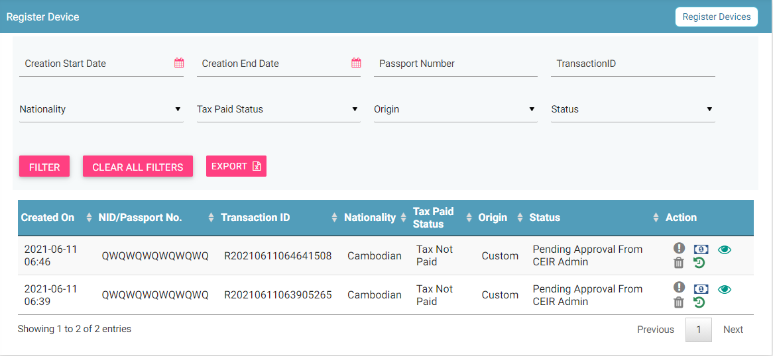

Figure 53: Filter Device Requests

1. Enter data in one or more of the listed fields:

* **Start** **Date** and **End** **Date**: This refers to the period of registering devices.
* **Transaction ID**: Each request is assigned a unique transaction ID.
* **Status:** Status of the request.
* **Tax Paid Status**: Whether tax has been paid for the device.

1. Click **FILTER**.

The requests that match the filter values are shown in the dashboard.

The user can clear all filters using the “**Clear All Filters**” button. This will reset all the filter values applied on the page and the data table will be refreshed.

## Sorting Register Device Requests

By default, all records displayed are sorted based on modified date. User can sort the records by clicking the arrow button on header in the table displayed.

On first click, the records are sorted in ascending order. When user clicks the arrow buttons again, records are sorted in descending order.

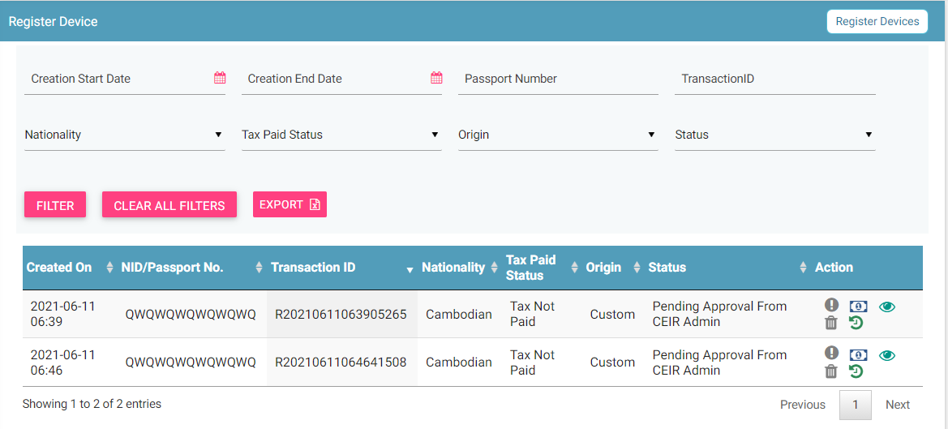

## Exporting Register Device Requests

Immigration officials can download all the uploaded requests in a **.csv** file. This is done using an export utility.

To export the uploaded requests:

1. On the **Register Device** page, click **Export**.



Figure 54: Register Device

The following page appears.

Figure 55: Open or Save Register Device File

1. Click **Open with** to view the **.csv** as an Excel file.



Figure 56: Exported Register Device File

Filtered data can also be exported. To do this, filter specific data by defining filter values. Refer to *Filter Register Device Requests* for information and then use the export feature to export the filtered data.